**How computing can be used for the growth of selected industry or a business**

**---Computing for Automobile Engineering---**

**Future Autonomous Vehicles and Security Options**

**Abstract**

There is a new trend in automobile industry to make autonomous vehicles. These vehicles are piloted and tested in countries like Netherlands, Singapore and USA present. These autonomous vehicles are using artificial intelligence and programming mainly. We all know that artificial intelligence is not proper than human intelligence. Autonomous vehicles are run under the traffic rules. Sometimes they couldn’t be get the right decisions and it causes to increasing traffic. And also there could be safety of privacy data issues in those vehicles programs like by hacking and changing privacy data those vehicles can be used for bad accepts like criminals and for get information about special persons. Usage of GPS and Scene identification by AI and Flying car system can input for reduce increasing the traffic by the autonomous vehicles. Usage of facial recognition systems and iris scanning systems are very useful to secure the privacy data of these autonomous vehicles. So this report discusses how those computing, IT related solutions which are mentioned above for increasing the decisions taking knowledge in a traffic situation and security of the data in autonomous vehicles.

**1. Introduction**

2..1The future is ultimately unknowable, but planning requires prediction of impending conditions and needs. Many planners, engineers and designers wonder how autonomous vehicles will affect future travel and planning for roads and make the safeness in modern vehicles using artificial intelligence technology. A one year ago some would have argued that autonomous vehicles never become a reality. But now they are being piloted in a number of countries and running on public roads. Netherlands is the number one for automated vehicle technology in the world then Singapore and after that USA. And also the Dutch ecosystem for autonomous vehicles is ready. The intensively-used Dutch roads are and developed and maintained. So the Ministry of infrastructure in Dutch government has opened the public roads to large scale tests with autonomous passenger cars and trucks. (Next generation Automotive-N Abid) So this is the trend of making a proper autonomous vehicle. Autonomous vehicles offer huge potential economic and social benefits. They could eliminate 90-95 percent of road accidents caused by human error, saving million lives every year. Because of most of them are run by electric they should also reduce road pollution. So because of these benefits like safeness etc. these intelligent vehicles will fulfill the roads in near 10 or 20 years. And also in near future we can see automated vehicles which can go land, air and water as well. (Autonomous vehicle implementation-Litman)

2.2) In everything there are good benefits but also some bad accepts. This software powered vehicles, there could be a problem by hacking those vehicles and use them for bad accepts and the traffic could be increase because of these autonomous vehicles. As an example sometimes those vehicles may be can’t understand the situation of the roads. In that time there should be a solution for that. And the privacy of the owner and the vehicle also need to be much secured. So we need to find how to increase these autonomous vehicles decision taking knowledge in a traffic situation and increase the security of the program and privacy. To that we can use computing in much better way. (Autonomous vehicles redlines index-Kmpg intentional)

**2. Literature review**

**2.1 Autonomous vehicles**

Experiments of autonomous vehicles have been conducted since 1920s and trail began in 1950s. Present vehicle companies like Audi, BMW are testing there self-driven autonomous vehicles. In 2004 Volvo company invented auto parking system by using sensors and cameras. Present by developing that system with using AI technology engineers developed auto braking systems also. (Wikipedia-autonomous vehicles) So Autonomous vehicles are based on these technologies. In 2017 Audi company invented their Audi A8 car which is automated at speed of up to 60kmh using there Audi AI technology. They use radar sensors gps systems to develop this. In 2018 US taxi service stared a project named Waymo which was the first (wkipedia,2018 self-driving safety report) autonomous taxi service in the world which is using databases and big data and AI technologies. In 2013 Terrafugia company invents first autonomous flying car also. (Next generation Automotive Embedded computing requirements and reference platform selection Issues-N. Abid Ali Khan))

2.2) Security options

To protect a vehicle, we use keys. First cars have internal cut keys and after that smart keys came. And also protect vehicle there are alarm systems. In 2014 BMW company invents mobile application for watch vehicle by using GPS technology and WIFY and present vehicle companies develop mobile apps to turn emergency lamps on get the location of the vehicle and increase the security of the vehicle by using satellite technology. (BMW owner’s manual, Toyota SAFETY sense owner’s manual)

Modern autonomous vehicle technology is developing very fastly but a few of inventors are thinking about the how to reduce the traffic which starts because of the autonomous vehicles and how to secure the privacy data I those vehicles.

So connecting these two parallel technologies we need to create find a proper solution for traffic which starts because of the autonomous vehicles and secure the privacy data of those vehicles

**3. Methodology**

Mostly autonomous vehicles are run under the artificial intelligence and using gps systems. Those autonomous vehicles use databases and internet self-thinking as the technique. Using these techniques, the autonomous vehicles are tested in countries like Singapore America.etc. Also those countries are testing flying cars, vehicles that can sail on the sea to reduce the traffic on those countries. Below image shows how autonomous vehicle drive by using commands and traffic instructions and it well define how the traffic can be increasing because of these autonomous vehicle technologies.

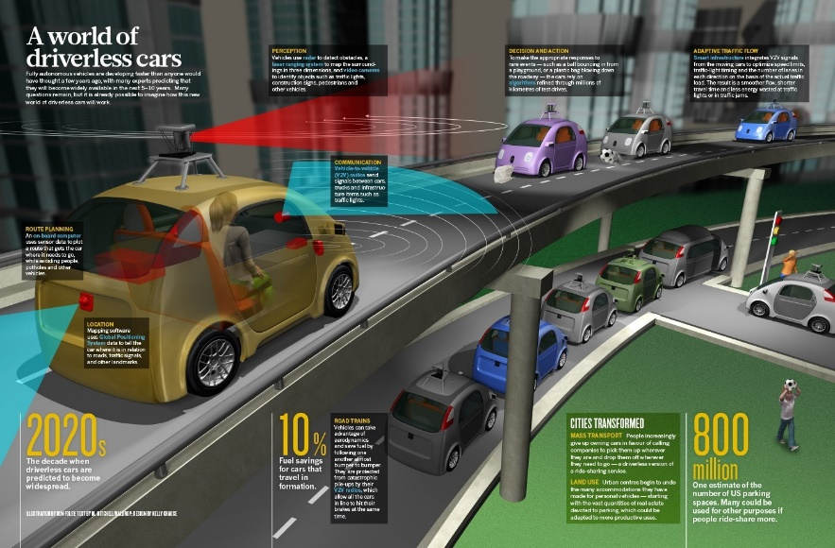

But none of the countries are not invented new security option except the smart key to a vehicle still. But most of mobile devices and vehicle entertainment systems are using AI technologies like gesture controlling, voice commanding and facial recognition. Today the most secure technology which are used for protect things is biometrical recognition. So we take a look how we can include those technologies to secure the database and programming based autonomous vehicles privacy data. Below Image shows how biometrical identification can have applied to a vehicle. Here the vehicle identifies both fingerprint and the face of the owner. So it’s more secure that using this technique to secure privacy data and program of the autonomous vehicle from hackers private agents.etc.

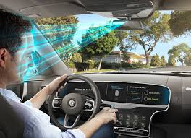

**4. Result and discussion: -**

**4.1 Problem**

4.1.1

Autonomous vehicles are based on artificial intelligence and programming. The vehicle control and body electronics control networks have been integrated with certain specialist network. And these vehicles run under tacking, speed control, guide assistance, traffic alerts and radio navigations etc. If these guide assist traffic lights will not work these autonomous vehicles cannot take the decision. So it causes to increasing traffic. Because lack of decision taking knowledge in autonomous vehicles transport data systems show significant potential for increasing traffic both on some sections on expressways and intersections of major urban roads. Below diagrams a past research of capacities for a single lane at a traffic signal in relation to clearance speed between autonomous driving and human driver.

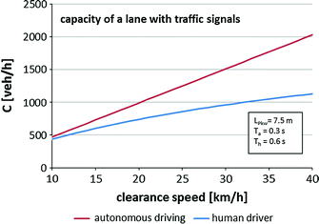

The effect of autonomous vehicles on traffic (Berhand Fredrich)

The city traffics a capacity increase of about 40% could be achieved with mainly autonomous traffic, while capacities could be increasing in some parts of expressway sections above 80%. In cities an Expressways vehicles are run under traffic lights, speed limits and other rules and regulations. Autonomous vehicles are programmed to get information from those traffic lights, speed limits etc... But if there are is accident or huge traffic human driver knows what to do next. He can take the decision by his own but autonomous vehicles can’t response to situation like that. So it causes the increasing of the traffic again.

4.1.2

Autonomous vehicles are powered by AI and programs. So if any one hack and got privacy data of those vehicles it’s a huge problem. Because it can use for bad accepts like stole things, do criminal accidents etc... But present autonomous vehicles haven’t any proper security option for this. They only use smart key as same as the human driven vehicles. There are some options like to check the surround of the vehicle and turn on emergency alarms etc. Those smart keys are using Bluetooth and radio technology but that is not enough for autonomous vehicle. Because in an autonomous vehicle there could be personal and privacy data of the owner of the vehicle and also the privacy data of the vehicle.

If someone hack an autonomous vehicles program and used it for kill someone, in that time the owner of the vehicle will punished under the criminal act. And if also terrorist, hackers and secret agents can get details of VIP persons like where they go, where they live by hacking those autonomous vehicles programs. So there should be more security for privacy data in autonomous vehicles.

**4.2 solution And Discussion**

4.2.1

To decrease traffic which starts because of the lack of knowledge to take decisions than the human driver in autonomous vehicle computing can be used easily. By GPS technology we can developed a program to find which road has the lowest traffic and command vehicle to go on that way. To this we also need artificial intelligence also. So as an example when autonomous vehicle goes threw a city to an urban area it could be choose a road which miss the city area and reach the destination by the application and its own program.

Modern autonomous vehicles are run under traffic lights and identify speed limits which showed in sides of the road. Those lights and commands are run by electricity mainly so if there is a power break down those command boards and lights will not work due to that vehicle can’t identify the situation of the road. So computing can use for this also to reduce the traffic starts because of this. We can include a database of speed limits of each road to the vehicle and get traffic lights details and traffic details from online. So by that database and online information vehicle van self-drive without increasing traffic in a problem like power break down.

4.2.2

To increase security of privacy data in autonomous vehicles present use smart key system is not enough. To that I suggest to include a biometric identification technology using computing. Present mobile phones use iris scanners, facial recognition and fingerprint sensor to protect privacy data in the device. In 2017 Apple company invented the facial recognition system to their mobile devices and in same year Samsung company includes much security option than facial recognition, Iris scanner which scan owners eye to access the device.

Autonomous vehicle is a digital device and also like a mobile device. It has all the privacy data of both the owner and the vehicle. So those data need to be much secured as how we protect data in our mobile devices. So unlock the vehicle, start the vehicle and change privacy data and access to those privacy data we need to move from key concept to those biometric identification technologies.

We can develop a program to identify owner including iris scanner, facial recognition or a system combined with both iris and facial recognition. By developing a program from these things we can secure privacy data in automated vehicles from hackers, secret agents and also from the terrorist. And also we can decrease criminal activities which can be done using autonomous vehicles.

**5. Conclusion: -**

Further research will be extended in secure the privacy data of the owners of the autonomous vehicles and the decreasing the traffic problem which starts because of the autonomous vehicles. To make a proper autonomous vehicle which is more secure, comfortable and more everything only solution is using computing to it.

Future we can accept some autonomous vehicles which can fly sail and drive to decrease traffic problems. Still some countries have invented flying cars. And in future we can accept that vehicle can self-identify the owner by the its artificial intelligence. Anyway because of these technologies which invented under the computing our lives going to be easy. So we can’t say this is the future of the autonomous vehicles exactly. But we need to keep in mind that secure the privacy data and find solutions for decreasing traffic problems.

**6. References: -**

1-The effect of autonomous vehicles on traffic (Berhand Fredrich)

2-The pathway to driverless cars summary report and action plan (Department of transportation _USA)

3-2018-self driving report (General motors)

4- Next Generation Automotive Embedded computing requirements and reference platform selection issues (N. Abid Ali Khan)

5-Autonomous vehicles redlines index (Kmpg intentional) 6-Autonomous vehicle implementation predictions (Todd litman)

6-Toyota safety sense owner’s manual

7-BMW owner’s manual